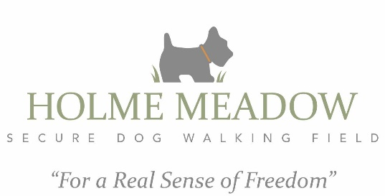

Terms and Conditions
Our Terms and Conditions are to ensure the safety and liability of your dog(s) whilst using Holme Meadow. Booking with us is deemed as agreement to these Terms and Conditions.
Booking, Payment and Cancelations
Use of Holme Meadow is strictly by appointment only. Bookings and Payment must be made in advance via our online booking system.
Customers must ensure they vacate our car park no later than the end time of their booking. Failure to do so will lead to the withdrawal of the facility for your use. Bookings are non-transferable to other people. Cancellations are not possible and payments will not be refunded. If you would like to reschedule your booking, please email us at least 48 prior to your booking.
Liability
We accept no responsibility for any damage, loss or injury that occurs on our premises. Whilst at Holme Meadow, you must accept full responsibility for your dog(s) and children. They must be supervised at all times. Our field is extremely secure but we cannot guarantee it is not possible for your dog to escape.
Facilities, Maintenance and Health and Safety
Holme Meadow is based in the countryside and there may be branches, uneven ground and brambles in the field. Customers must pick up dog faeces and dispose of it in the dog waste bin provided. Owners must discourage their dog(s) from digging, and any resultant holes must be filled in prior to leaving the field. There is a water tap on side. ‘Holme Hut’ is a wonderful shelter should you need to escape any adverse weather conditions and is the perfect place for a picnic, however all litter must be taken home.

Code of Ethics
Owners must ensure that all dogs using Holme Meadow are up to date with flea, worming and tick control. If your dog(s) or any dogs they live with, are showing any signs of ill health (coughing, diarrhoea, vomiting, general illness etc) you will need to cancel any pending booking. This is to preserve the health of all dogs visiting Holme Meadow.
COVID-19
Please adhere to the current government guidelines. Please use hand sanitiser before and after touching the gate.
DATA
We only retain your contact details in the event of having to contact you regarding your booking. The information is not shared to any other parties

